

**DESIGNINSPIRE - an international exhibition about creativity**

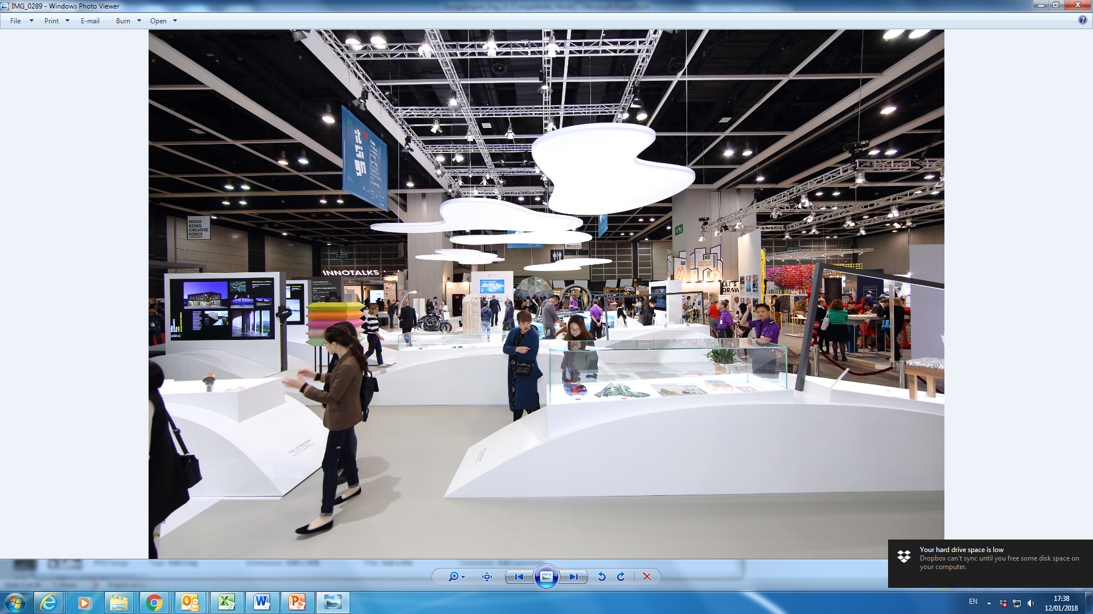

**DESIGNINSPIRE** is an international exhibition about creativity and innovation.  It gathers the foremost design products and innovative solutions with creativity, technology and commercial potential to inspire business opportunities. It is a one-stop marketplace with an array of innovative design ranging from architectural, digital, experience, graphics, industrial and spatial, to urban and culture.

**DESIGNINSPIRE** annually partners with Business of Design Week (BODW) and a world’s creative economy to present a comprehensive exhibition. **United Kingdom** is the partner Country of DesignInspire 2019 and will explore how design and design thinking will influence how we WORK, LIVE, PLAY and LEARN.

|  |  |  |
| --- | --- | --- |
| **Date** | **Opening Hours** | **Visitors Registration Hours** |
| 5-6 Dec (Thu - Fri):  7 Dec (Sat): | 9:30 am – 7:00 pm  9:30 am – 6:30 pm | 9:00 am – 6:30 pm  9:00 am – 6:00 pm |

Location: Hong Kong Convention and Exhibition Centre (Halls 3DE)

Register for **FREE** admission: [www.hktdc.com/ncs/designinspire2019/en/s/Visitor-Registration.html](http://www.hktdc.com/ncs/designinspire2019/en/s/Visitor-Registration.html)

Website: www.hktdc.com/ncs/designinspire2019/tc/main/index.html



【**DesignInspire創意設計博覽】**

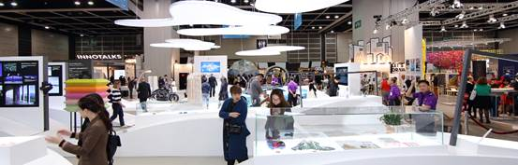

**DESIGNINSPIRE** 是以創意及創新為題的國際性展覽，集合創新科技和嶄新設計，創造商機。展覽展示各式各樣的創新設計，從建築、數碼、體驗、平面、工業、空間，城市設計，融合創新文化，激發無限創意。

**DESIGNINSPIRE**及設計營商周每年聯同一個設計國家或城市，舉辦主題館、論壇、講座及交流活動等，將當地優越的創新設計帶來香港。2019年的夥伴國為英國。

博覽日期：2019年12月5-7日

開放時間：上午9時30分至下午7時 (12月7日至下午6時30分)

博覽地點：香港會議展覽中心

免費登記入場：<http://www.hktdc.com/ncs/designinspire2019/en/s/Visitor-Registration.html>

網站：www.hktdc.com/ncs/designinspire2019/tc/main/index.html