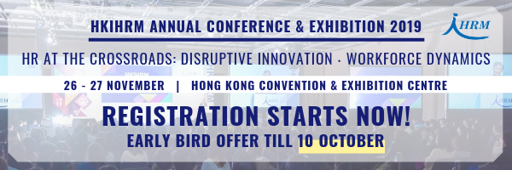

Delegate Registration Opens for the HKIHRM Annual Conference & Exhibition 2019
First 10 members from CMAHK will enjoy 15% off on Non-member rate!
(Please apply promotion code upon registration: AC19CMA10_SO)

Entitled “HR at the Crossroads: Disruptive Innovation．Workforce Dynamics”, the 2019 Annual Conference & Exhibition is now open for registration! 30+ renowned speakers from the region and around the globe will share their insights into the conference theme as well as some of the HR hot topics during November 26-27 at the Hong Kong Convention & Exhibition Centre.

Highlights
- Plenary sessions: High-level insight sharing from Keynote speakers, CEOs, HR chiefs and young leaders, renowned Inspirational speaker
- Concurrent sessions: Discussion with industry experts on various pressing HR issues
- Free access to Exhibition Hall, Symposiums, and Workshops
- Expecting 50+ exhibitors and 1,200+ HR professionals from local and overseas

Conference Programme
 | Nov 26 (Tue) | Nov 27 (Wed)
AM | Opening Remarks by Guest of Honour | Keynote Speech
 | Keynote Speech
 | Refreshment Break
 | 4-5 Concurrent Sessions A | 4-5 Concurrent Sessions C
PM | Lunch
 | CEO Forum | Young HR Forum
 | Coffee Break
 | 4-5 Concurrent Sessions B | 4-5 Concurrent Sessions D
 | Refreshment Break
 | Senior HR Forum | Inspirational Speech

Registration Fees

Entry Pass Option | Early Bird  (Until 10 Oct) |  |  | Regular Price  (After 10 Oct)
 | *New Member | Member | Non-Member | *New Member | Member | Non-Member
Two-day (All access) | HK$6,650 | HK$7,800 | HK$9,400 | HK$7,650 | HK$8,950 | HK$10,800
Two-day (Concurrent Sessions only) | HK$4,450 | HK$5,200 | HK$6,300 | HK$5,100 | HK$5,950 | HK$7,200
One-day (All access) | HK$3,750 | HK$4,400 | HK$5,300 | HK$4,350 | HK$5,100 | HK$6,150
Remarks:
- * To apply for this ticket, you must join the HKIHRM as a new member during the period of April 1 to November 27, 2019.
- Lunch is not included in the entry pass.

Sign up now to enjoy early bird offer!

About HKIHRM
The Hong Kong Institute of Human Resource Management (HKIHRM) is the most representative professional human resource institute in Hong Kong. The Institute aims at developing, maintaining and enhancing professional standards in HR management, while increasing the value and influence of the HR profession. Established in 1977, the Institute has around 5,300 members, with 600 of whom being corporate members.

Enquiries and sponsorship opportunities:
T: (852) 2837 3822 / 17 | E: project@hkihrm.org | Conference Website

