Training Course on “Grid Connected Renewable-Energy Power Generation Systems”

A Feed-in-Tariff (FiT) Scheme was introduced by power companies to promote renewable energy -- e.g. wind or solar energy – applications. New renewable energy facilities will be installed and connected to the main power grid. Green Council will provide a series of training course to enhance the capacity including technical knowledge and skills for the engineering professionals and environmental consultants who are or will become responsible for marketing, design, installation and/or management of RE power generation systems.

Details
Date and Time: 18:30-21:30 (14-Nov, 21-Nov, 28-Nov and 5-Dec) and 9:30-12:30 (16-Nov)
Total training hours: 15 hours
Maximum: 40 candidates per lesson
Language: Cantonese (Course materials in Chinese or English)
Contents and Address: See below
Fee: Free of charge

Certificate
There will be a written test after each lesson. Students who passed all the tests and attended all workshops will be presented with a certificate --- “Certified Professional for Grid Connected Renewable-Energy Power Generation Systems”

Supporting Organizations:
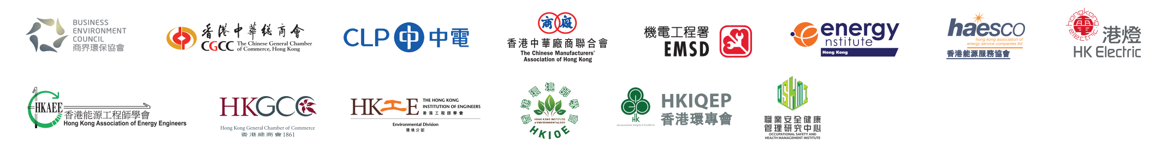

Content of Course | Instructor | Time | Venue
- Electrical installation and Grid connection of Renewable Energy Systems  - Interface and Commissioning requirements for grid connection RE systems  - Technical requirements and consideration of grid connection | Representatives from CLP and HEC | 14-Nov  (THU) | Room 202E, Business Environment Council,77 Tat Chee Avenue, Kowloon Tong.
 |  | 6:30pm-  9:30pm | 九龍塘達之路77號商界環保協會202E室
- Procurement of Renewable Energy Solar PV Components and Materials  - Selection of materials and equipment  - Proper design and installation of a RE PV power system  - Demonstration  - Repair and maintenance | Representatives from Hong Kong Baptist University | 16-Nov (SAT)  9:30am-  12:30pm | G/F, Jockey Club School of Chinese Medicine Building,  Hong Kong Baptist University,  7 Baptist University Road, Kowloon Tong  九龍塘浸會大學道 7號  香港浸會大學賽馬會  中醫藥學院大樓地下  孔憲紹博士伉儷講堂 （SCM012室）
- Planning and Design of Renewable Energy Systems  - Assessment of solar energy and potential for customers  - FiT scheme application procedures and other key features and aspects | Representatives from CLP and HEC | 21-Nov (THU) | Room 202E, Business Environment Council,77 Tat Chee Avenue, Kowloon Tong.
 |  | 6:30pm-  9:30pm | 九龍塘達之路77號商界環保協會202E室
4. Law and Regulations related to Photovoltaic (PV) installation including Electricity requirements; and  Building requirements (installations in private development & NT exempted  houses, erection of supporting structure under minor works control system) | Representatives from BD & EMSD of HKSAR  government | 28-Nov (THU)  6:30pm-  9:30pm | Room 202E, Business Environment Council,77 Tat Chee Avenue, Kowloon Tong.  九龍塘達之路77號商界環保協會202E室
- Safety Working Practices  - PV power systems  - at height and at rooftops  - relevant safety regulations | Representative from Occupational Safety & Health Management Institute and  YY Wong Safety Consultants Ltd. | 5-Dec (THU)  6:30pm-  9:30pm | Room 202E, Business Environment Council,77 Tat Chee Avenue, Kowloon Tong.  九龍塘達之路77號商界環保協會202E室
Total: |  | 15hours
*This material/event is funded by the Professional Services Advancement Support Scheme of the Government of the Hong Kong Special Administrative Region. Any opinions, findings, conclusions or recommendations expressed in this material/any event organised under this project do not reflect the views of the Government of the Hong Kong Special Administrative Region or the Vetting Committee of the Professional Services Advancement Support Scheme.

Language
Cantonese (course materials in Chinese or English)
Course Fee
Free of Charge

